Checklist T-1, Part 1 (Treatment BMPs)

Treatment BMPs
Checklist T-1, Part 1
Prepared by: Date: District-Co-Route:
PM: Project ID/EA: RWQCB:
Consideration of Treatment BMPs
This checklist is used for projects that require the consideration of Approved Treatment BMPs, as determined from the process described in Section 4 (Treatment Consideration) and the Evaluation Documentation Form (EDF). This checklist will be used to determine which Treatment BMPs should be considered for each BMP contributing drainage area within the project. Supplemental data will be needed to verify siting and design applicability for final incorporation into a project.
Complete this checklist for each phase of the project. This will help to determine if any changes to the BMP strategy are necessary, based on site specific information gathered during later phases. Use the responses to the questions as the basis of developing the narrative in Section 6 of the Stormwater Data Report to document that Treatment BMPs have been appropriately considered and/or incorporated.
Before evaluating an area for treatment capabilities or to incorporate a Treatment BMP, calculate the numeric sizing requirement for each contributing drainage area (WQV from the 85th percentile 24-hour storm event or WQF rate). Soil and geometric information for the project area will be necessary to use this Checklist.

Identify the overall project PCTA
Refer to Section 4.3 Treatment Areas for more information on defining these areas.
PCTA = NNI + RIS – EIA + ATA (1); OR ATA (2)
NNI = Net New Impervious Area
RIS = Replaced Impervious Surface
EIA = Excluded Impervious Area
ATA (1) = Additional Treatment Area required for existing Treatment BMPs that were removed or modified as part of the project
ATA (2) = Additional Treatment Area required when NNI is greater than 50 percent of total project impervious
What is the PCTA for the project? Acres (A in Table E-1)
The PCTA is the area required to be treated by the project. The PE is to incorporate BMPs until the summation of the treated impervious area of all the BMPs is equivalent to the PCTA for the Project.
Once the PCTA has been treated, the project is in compliance with the post construction treatment requirement.
Total Maximum Daily Load (TMDL) Retrofit Projects
If the project is installing Treatment BMPs to only address TMDL requirements, then there is no required PCTA. The Treatment BMPs for a TMDL retrofit project should be designed to treat impervious and pervious contributing drainage areas in accordance with the TMDL Compliance Plan.
Overall Project Evaluation
Answer all questions, unless otherwise directed.
- Overall Project Consideration
  - Is the project in a watershed with prescriptive Treatment BMP requirements in an adopted TMDL implementation plan or are there any other requirements for project area as described in the WQAR (e.g., District, RWQCB, Consent Decree)? Yes No
If Yes, consult the District/Regional Design Stormwater Coordinator or District/Regional NPDES Coordinator to determine if there are written agreements related to specific Treatment BMPs. In this case, determine if the rest of this checklist needs to be followed to address other post construction requirements. If not, document BMP(s) in the Individual Treatment BMP Summary Table, provide information on the basis of the BMP requirement and any regulatory coordination in the SWDR narrative, and complete Table E-2. Otherwise, continue.
If No, continue.
  - Does the receiving water have a TMDL for litter/trash, is there a region specific requirement related to trash, or is the project in an STGA? Yes No
If Yes, first evaluate Multi Benefit Trash Treatment Systems that can treat other pollutants and are considered to be full-capture trash devices (Infiltration Basins/Trenches, Detention Basins, Media Filter, Bioretention). If Multi Benefit Trash Treatment Systems cannot be sited, determine if standalone full-capture devices (GSRDs, Trash Nets, Capture Housing) can be sited.
If Multi Benefit Trash Treatment Systems or standalone full-capture devices are incorporated and no other Treatment BMPs are being considered, go to question 6 of “Individual BMP Evaluation”. If full-capture devices are incorporated and additional Treatment BMPs are being considered, continue.
If No, continue.
  - Is the project located in an area that uses traction sand more than twice a year? Yes No
If Yes, first consider BMPs that can treat other pollutants and can capture traction sand. If other BMPs cannot be sited, consult the District/Regional Design Stormwater Coordinator to determine if standalone traction sand trap devices should be incorporated.
If standalone devices are required and no other Treatment BMPs are being considered, go to question 6 of “Individual BMP Evaluation”. Otherwise, continue with this checklist to identify Treatment BMPs that provide traction sand and other pollutant removal, or to design Treatment BMPs in series.
If No, continue.
- Dual Purpose Facilities
  - Does the project have (or propose to include) any dual purpose facilities that could meet treatment requirements
(e.g., Dry Weather Flow Diversion, flood control basins, etc.)? Yes No
If Yes and 100 percent of the PCTA and ATA 1 (Pervious) will be treated by the dual purpose facility, go to question 6 of “Individual BMP Evaluation”.
If Yes, but 100 percent of the PCTA and ATA 1 (Pervious) has not been addressed, continue.
If No, continue.
- Evaluate overall project area for infiltration opportunities using existing and proposed roadside surfaces (DPPIAs). Assure the DPPIA is stabilized to handle highway drainage design flows, for both sheet and concentrated flows (See HDM Section 800).
Document DPPIAs on the “Individual Treatment BMP Summary Table” located at the end of this checklist.
  - Based on site conditions, do the DPPIAs infiltrate 100 percent of the WQV generated by the PCTA and ATA 1 (Pervious) for the project? Yes No
Yes, go to question 6 of “Individual BMP Evaluation”.
If No, account for area infiltrated and continue.
  - Can infiltration for these areas be increased by using soil amendments or other means? Yes No
If Yes, and 100 percent of the WQV generated by the PCTA and ATA 1 (Pervious) is infiltrated, go to question 6 of “Individual BMP Evaluation”.
If Yes, but 100 percent of the WQV generated by the PCTA and ATA 1 (Pervious) is not infiltrated, continue with this checklist to identify Treatment BMPs that will treat the remaining PCTA and ATA 1 (Pervious).
If No, continue.
Individual BMP Evaluation
Answer the following questions for each Treatment BMP location being considered. The following process must be followed until the PCTA and ATA 1 (Pervious) or desired treatment area (Alternative Compliance) has been achieved. Use the Individual Treatment BMP Summary Table at the end of the checklist to summarize the selected BMP(s) based on the findings of the following questions for each BMP contributing drainage area.
- Infiltration Devices (Infiltration Basin, Trench, Gallery, or other device)
  - Can 100 percent of the BMP contributing drainage area WQV (or remaining WQV, if in series with a DPPIA or other BMP) be infiltrated? Yes No
If Yes, go to question 6.
If No, continue.
- LID flow through Devices (Biofiltration Strips, Swales, & Bioretention)
  - Is this a TMDL retrofit project or is the project within a TMDL watershed or 303(d) impaired receiving water body area? Yes No
If Yes, when designing the TBMP device, determine the percent WQV infiltrated from both the impervious and pervious BMP contributing drainage areas. Consider using existing or amended soils:
If infiltration is >50 percent, continue to b.
If infiltration is ≤50 percent, go to question 3.
If No, continue to b.
  - Can LID flow through devices be designed to: Yes No
Infiltrate 100 percent of the WQF/WQV (or remainder, if in series with a DPPIA or other BMP) from the BMP contributing drainage area, and
Meet the siting and design criteria of the Caltrans TBMP design guidance.
If Yes, continue to b.
If No, go to question 3.
  - LID flow through devices are considered to be an effective method of treatment, go to question 6.
- Earthen type BMPs (Detention Devices, Media Filters, or other devices)
  - Can earthen type BMPs (standalone or in series with other approved Treatment BMPs) be designed to: Yes No
Infiltrate 100 percent of the WQV (or remainder, if in series with a DPPIA or other BMP) from the BMP contributing drainage area, and
Meet the criteria of the Caltrans design guidance for the treatment device being considered.
If Yes, continue to b.
If No, go to question 4.
  - Earthen type BMPs are considered to be an effective method of treatment, go to question 6.
- Targeted Design Constituent (TDC)
This approach will compare the effectiveness of individual BMPs and allow the PE to use judgment when evaluating BMP feasibility (site constraints, safety, maintenance requirements, life-cycle costs, etc.).
  - Does the project discharge to a 303(d) impaired receiving water or a receiving water in a TMDL watershed where Caltrans is a named stakeholder? Yes No
If Yes, is the identified pollutant(s) considered to be a TDC (check all that apply below)? Continue to b.
sediments copper (dissolved or total)
phosphorus lead (dissolved or total)
nitrogen zinc (dissolved or total) general metals (dissolved or total)
If No or if no TDC is identified, use Matrix A to select BMPs and go to question 5.
  - Treating Only Sediment. Is sediment a TDC? Yes No
If Yes, use Matrix A to select BMPs and go to question 5.
If No, continue to c.
  - Treating Only Metals. Are copper, lead, zinc, or general metals listed TDCs? Yes No
If Yes, use Matrix B to select BMPs, and go to question 5.
If No, continue to d.
  - Treating Only Nutrients. Are nitrogen and/or phosphorus listed TDCs? Yes No
If Yes, use Matrix C to select BMPs, and go to question 5.
If No, continue e.
  - Treating both Metals and Nutrients. Is copper, lead, zinc, or general metals AND nitrogen or phosphorous a TDC? Yes No
If yes, use Matrix D to select BMPs, and go to question 5.
If No, continue.
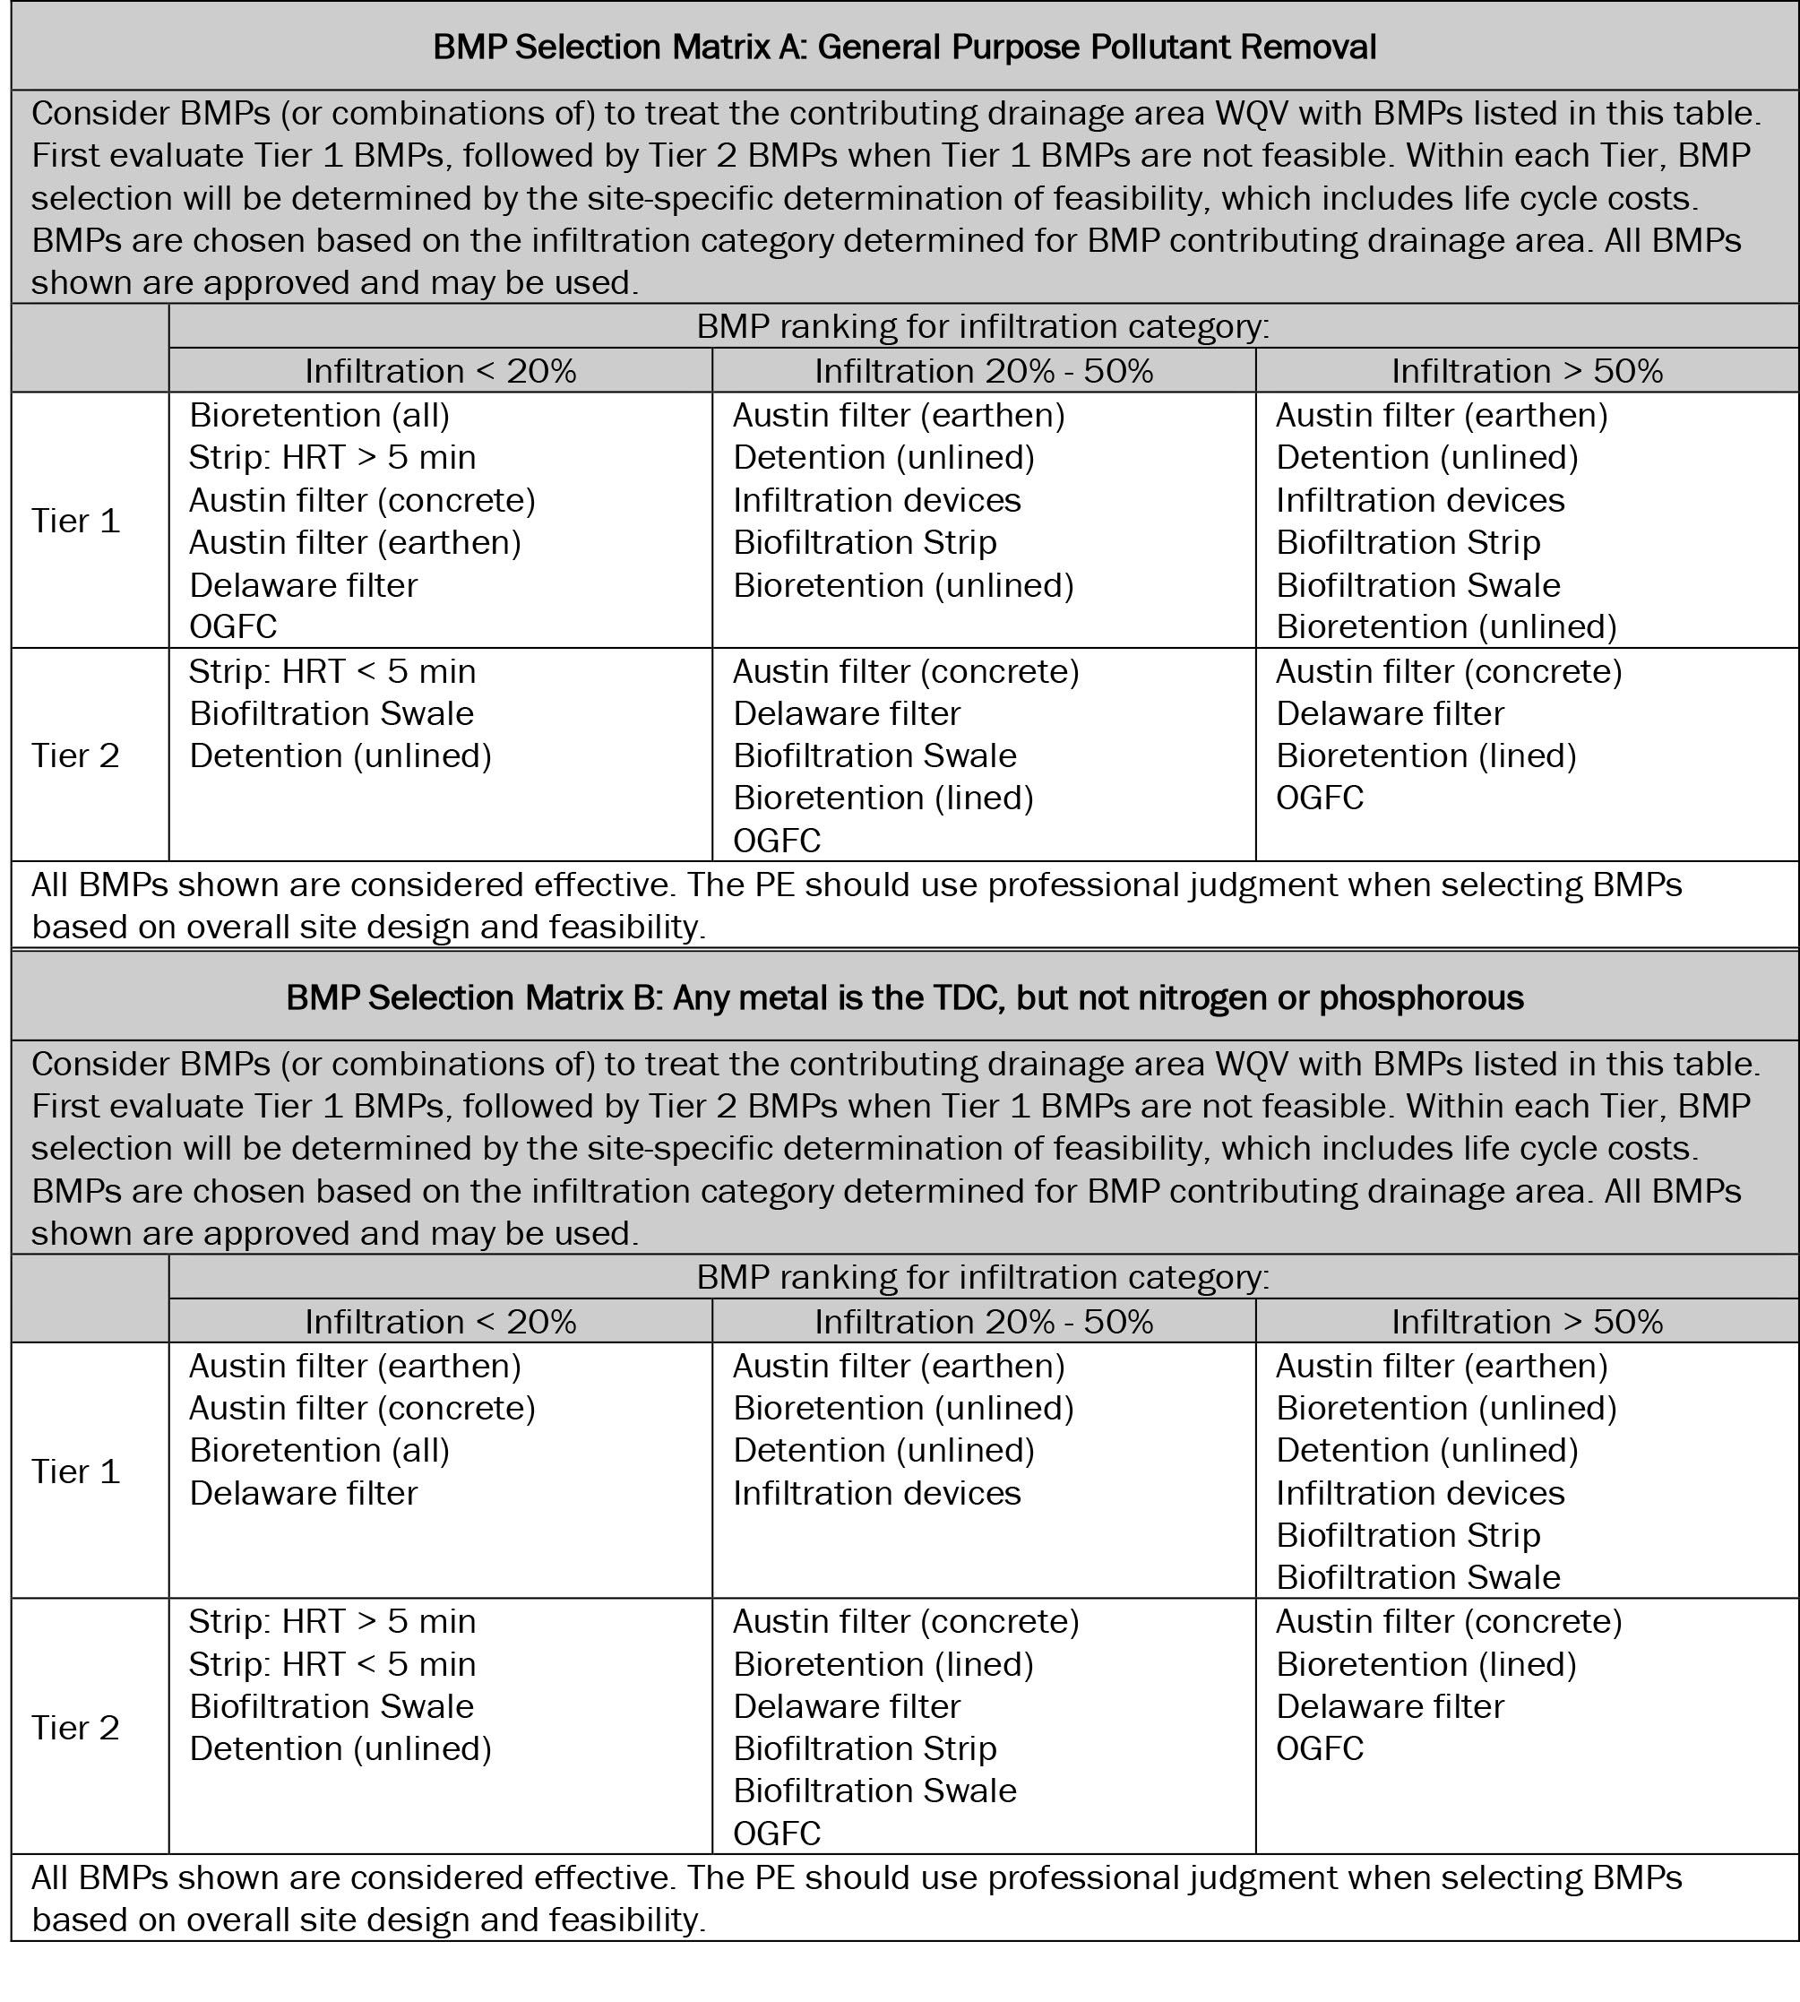

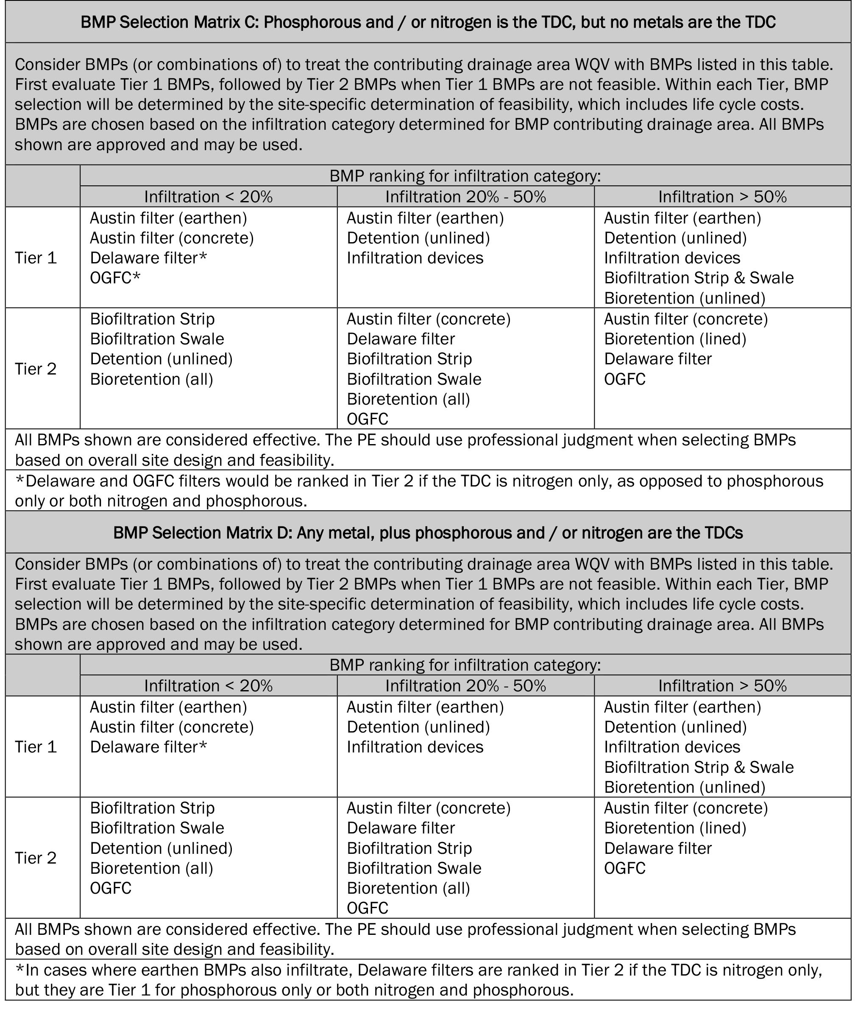

- Does the project discharge to a 303(d) receiving water that is listed for mercury or low dissolved oxygen? Yes No
If Yes, contact the District/Regional NPDES Coordinator to determine if standing water in a Delaware Media Filter, Wet Basin, or other TBMP would be a risk to downstream water quality. Continue to question 6.
If No, continue to question 6.
- Identify the Treatment BMPs being considered and complete the Individual Treatment BMP Summary Table and Overall Project Treatment Summary Table on the following pages. Refer to Appendix B of the PPDG and review the checklists identified below for every Treatment BMP under consideration. Complete
Document the basis of design in the SWDR narrative and complete Table E-2.
____ DPPIAs: Checklist T-1, Part 11
____ Infiltration Devices: Checklist T-1, Part 2
____ Biofiltration Strips and Biofiltration Swales: Checklist T-1, Part 3
____ Detention Devices: Checklist T-1, Part 4
____ Traction Sand Traps: Checklist T-1, Part 5
____ Dry Weather Diversion: Checklist T-1, Part 6
____ GSRDs: Checklist T-1, Part 7
____ Trash Net: Checklist T-1, Part 7
____ Capture Housing: Checklist T-1, Part 7
____ Media Filter [Austin Sand Filter and Delaware Filter]: Checklist T-1, Part 8
____ Bioretention: Checklist T-1, Part 13
____ Open Graded Friction Course (OGFC): Checklist T-1, Part 12
Note:
Multi-Chamber Treatment Train (MCTT) is not listed here because Caltrans has found that other approved BMPs are equally effective and more sustainable due to lower life cycle costs.
Wet Basins are not listed here due to feasibility issues due to site feasibility and issues with long term operation and maintenance.
Pervious Pavement is not listed here because pervious pavement can only be used for non-highway areas.
MCTT, Wet Basins, and Pervious Pavement may be considered or implemented upon the recommendation of the District/Regional Design and Maintenance Stormwater Coordinator.
- Prepare cost estimate, including right-of-way, and document pertinent site specific determination of feasibility for selected Treatment BMPs and include in the SWDR for approval. Complete
Individual Treatment BMP Summary Table
List the selected BMPs based on the findings of this checklist and the treated areas associated with each BMP in Table E-2. For projects with multiple BMPs, add rows (if needed), or attach a separate sheet displaying the following information.
Each BMP must be tracked in Table E-2. Districts may use a modified table based upon their needs. See Section 6.6 for additional information.
Table E-2. Individual Treatment BMP Summary Table ¹
BMP Identifier-Number | BMP  Type | Treated Impervious Area (CT RW) (ac) | Treated Impervious Area (Outside CT RW) (ac) | Treated Pervious Area (CT RW) (ac) | Treated Pervious Area (Outside CT RW) (ac) | Treated WQV/WQF/  FCV/FCF (%)
 | Total Area to be Treated (acre) | (B in Table E-1) | (C in Table E-1)
¹ The treated areas identified in this table are a product of the BMP CDA and Treated WQV/WQF/FCV/FCF (%).

If existing treatment BMPs are in TMDL areas and the pervious tributary area for the BMP has been documented for TMDL Compliance then the TBMP Pervious Area must also be added to ATA 1.
General metals is a designation used by Regional Water Boards when specific metals have not yet been identified as causing the impairment.

